AWS Cloud Infrastructure Plan

for

Symbiosis

1. **Introduction**

Symbiosis is a health product manufacturing company and currently on-premises infrastructure.

They have recognized the benefits of moving to a cloud infrastructure & would like to evaluate

an AWS cloud solution.

Based on their priorities and internal discussions, they have provided you with some high-level

requirements which they would like you to implement in the proposed solution. The high-level

requirements are as follows:

A private isolated network which would best suit Symbiosis’s 2 tier architectural needs.

In order to meet their internal SLA’s they require a highly available solution as well.

Symbiosis being a B2C company, would typically like their web applications to be

accessible over the internet and thus handle HTTP traffic.

The database tier should have restricted access (not open to HTTP) and allow traffic

only through the web tier.

They would like to reduce the administrative burden of managing their SQL database

and requires a managed database for their SQL engine in the proposed solution. They

need the database to be highly available.

Currently they experience medium to high traffic on their network. The traffic to the web

tier is managed by a load balancer which diverts traffic to healthy instances. They would

ideally like a Load Balancer with an ability to perform layer 4 (Transport Protocol) and

layer 7 (Application) checks while balancing the load. There is no requirement at this

point to balance the load on the database tier.

In their current setup, the traffic being inconsistent, requires over provisioning resulting in

increased costs. In order to overcome this issue, they would like the new system to allow

automatic scaling in the event of a traffic spike

1. **Background Discussions**

Following needs were identified during the discussions

1. Application should be scalable.
2. Application should be available throughout.
3. Security of the app and most importantly data is of utmost important.
4. Infrastructure will be created under the Virtual Private Cloud so that it’s secure and database is not accessed from external networks.
5. Product will be accessed globally in the short run
6. Load balancer to perform L4 to L7 checks.
7. Autoscaling of the instances.
8. Database multi-az.
9. **Present Symbiosis Technology Infrastructure**

App Server

Db

The current architecture with physical infrastructure.

The physical infrastructure consists of 3 web servers through load balanced to app server and db instances.

1. **Recommended AWS Architecture**

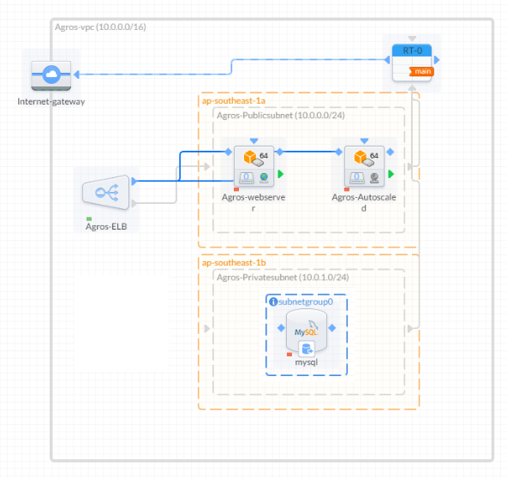

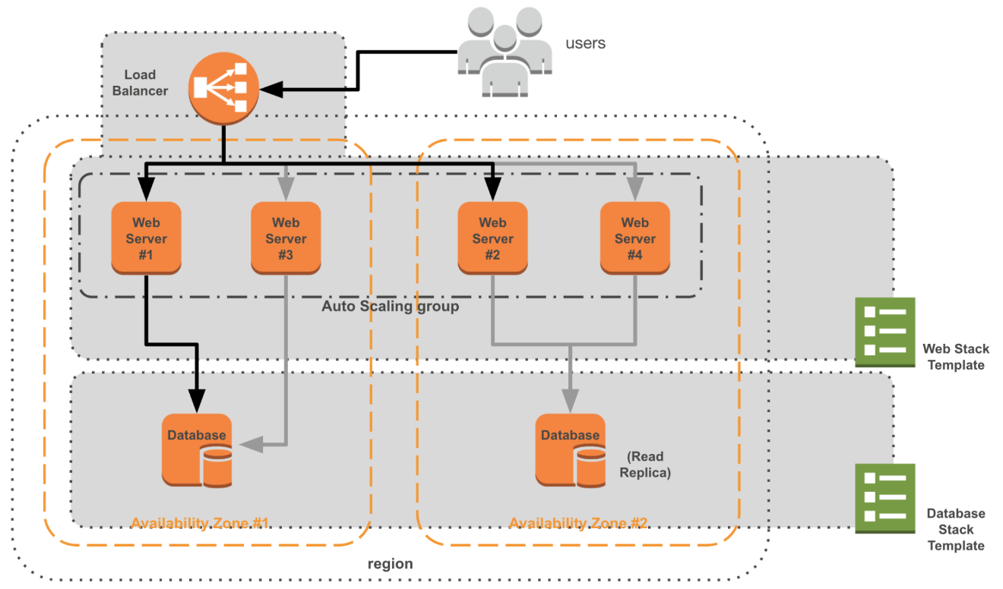

As per the infrastructure diagram above following would be provisioned:

1. A Secure Virtual Private Cloud to be configured
2. Cloud to run Amazon Linux AMI instances. It has been recommended to use Amazon Linux AMI primarily to reduce the hosting cost by approximately 40% per month.
3. Base instance image to have LAMP Stack with Apache installed
4. A MySql RDS will be configured accessible only via a private IP through the server
5. The Mysql database will be configured with **Multi-AZ** as per the client requirements.
6. The Architecture will be created in the **Singapore** region
7. Auto scaling will be configured for low latency and high availability of the application
8. Automated backups will be configured in RDS.
9. ELB will be configured for layer 4 to layer 7.

**Other Resource Configurations:**

1. Cloud front will be configured for CDN use. (If client requires)
2. S3 Bucket will be configured for Cloud Front. (If client requires)
3. Elastic Cache will be configured. (If client requires)
4. **Backups and Images**

Since the servers would be running under a Load Balanced environment it’s important that the base image is always updated as soon as the application is updated. Therefore, image update and configuration needs to be a part of production release.

RDS will automatically create database snapshots.

1. **Next Steps:**

Set up will be created with the recommended architecture. Application and database needs to be configured on the servers configured.

Test will be conducted to check:

1. Infrastructure availability and accessibility
2. Auto Scale Simulation
3. Instance Failover recovery test
4. Back up configuration and recovery test
5. Database crash recovery test.
6. **CI/CD Workflow.**

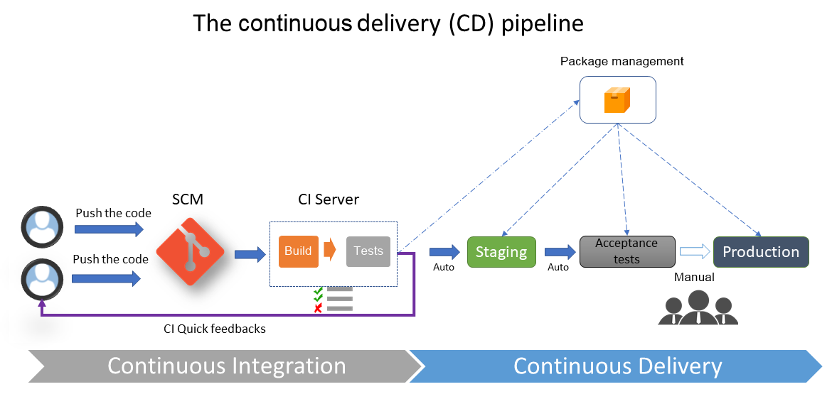

**1. Git-standalone, SonarQube, docker, jenkins -docker**

**nexus storage artifacts.**

**k8s 1 master 1 slave minimum**

**a) docker registry -server**

**docker manager server-kubectl installed**

**2 slave**

**b) git -build--nexus-storage--ci/cd build deploy package**

**CI/CD – lower environment.**